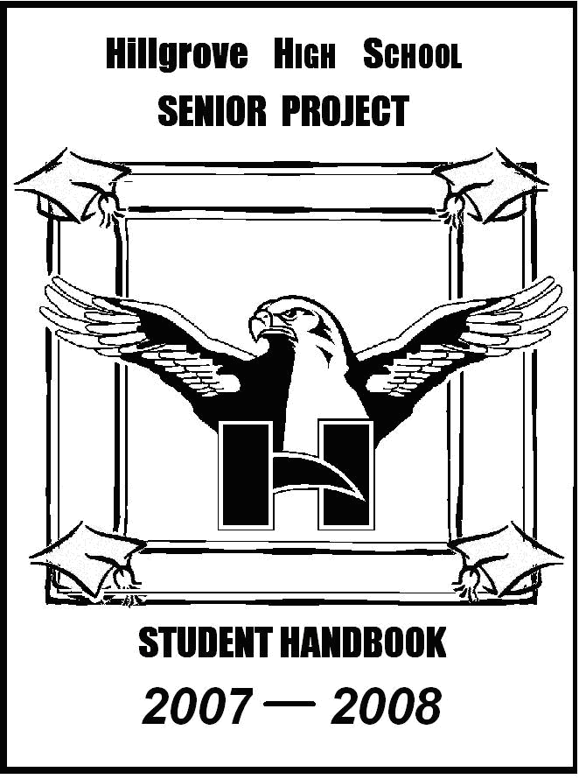
MENTOR MANUAL

2019-20120

Hillgrove High School

SENIOR PROJECT 2019-2020

Principal
Angela Stewart

Senior Project Steering Committee

Senior Project Coordinator: Aliyyah Salam
Assistant Principal for Senior Project: Mark Giles
English Department Chair: Dr. Sylvia Spruill

4165 Luther Ward Road
Powder Springs, GA 30127
Phone: 678-331-3961
Fax: 678-331-8128

Hillgrove High School Senior Project Mentor Manual
2019-2020

TABLE of CONTENTS

Letter to Mentors 1
Mentor Qualifications and Responsibilities 2

LETTER to MENTORS
Dear Senior Capstone Mentor,

A student has solicited your assistance with his/her Senior Capstone because he/she has determined you to be skilled and/or experienced in a particular field of interest and/or research. The student would like for you to advise and oversee the production of his/her Senior Capstonet product. Thank you for agreeing to be a Senior Capstone Mentor!

Senior Capstone allows each senior the opportunity to explore a career that they are either interested in or have aptitude for while they demonstrate his/her years of educational experience in reading, writing, speaking, accessing information, thinking, problem solving, organizing and time-managing. These skills will be showcased in a three-part process, consisting of the following components:
- a word-processed research paper on a topic of the student's choosing
- a physical product, performance, skill, or service to the community related to some aspect of the research paper, guided by a student-selected mentor
- an oral presentation synthesizing the first three components. The oral presentation is given before a review board of teachers and community members.

In addition, each student is asked to set a SMART goal for their learning and product. This SMART goal should outline what the student hopes to learn and how they plan on showcasing that learning.

To be successful, the student must complete and pass all components of the project, which together comprise a major percentage of the senior English grade.

All questions, concerns and/or communications should be sent to either the Senior Project Mentor Coordinator who oversees all mentor affairs, or directly to the student’s English teacher, who is responsible for the student’s final grade.

All of us connected with the Senior Capstone at Hillgrove sincerely appreciate your willingness to support this program by serving as a mentor. We hope your experience is a rewarding one.

Aliyyah Salam-Abdullah, Senior Project Coordinator

HHS SENIOR CAPSTONE MENTOR QUALIFICATIONS & RESPONSIBILITIES

Mentor Qualifications:
- Faculty members of Hillgrove High School cannot serve as student mentors
- Mentor cannot be a family member of the student
- Mentor must be 21 years of age or older
- Mentor must be an expert or professional in the field/area of mentoring

Mentor Responsibilities:

- Advise and assist the student with the development of a SMART goal, which will include a product (which may be a physical product, a performance, a skill, or a service to the community).
- Mentors should help the student establish a time frame for completing the product, a list of resources and materials needed, a projected cost for completing the product, and a schedule for meeting with the student. Students must log in a minimum of 10 contact hours with the mentor in order to get full credit for this requirement.
- Complete the Mentor Log at the conclusion of each meeting, after student has recorded the appropriate information for the session.
- Complete small videos with the students at different intervals to discuss the student’s progress (proposal, 5 hour, and 10 hour)

The student’s Senior Capstone product and other documentation must be completed by the deadlines indicated on the Pacing Guide for each semester. Failure to turn in assignments on time, may have negative consequences for the student’s grade.

SMART goal and proposal flipgrid- August 23

5 hour mentor check flipgrid- September 9

10 hour mentor check flipgrid- October 18

HHS

Aliyyah Salam-Abdullah
Senior Project Coordinator
Hillgrove High School
4165 Luther Ward Road
Powder Springs, GA 30127

678-331-3961

Aliyyah.salam@cobbk12.org

